Picture Composition
Picture Composition is the art of writing a short and meaningful paragraph by looking carefully at a picture. We use the picture as a guide and describe the people, places, objects, actions and events shown in it.

Points to Remember
- Observe the picture carefully.
- Identify the place and setting.
- Mention the people, animals or objects in the picture.
- Describe what they are doing.
- Add suitable details such as time, weather, colours or surroundings.
- Arrange the ideas in a proper order.
- Use simple and correct sentences.
- Give a suitable title.
- Write the composition as a connected paragraph, not as separate answers.
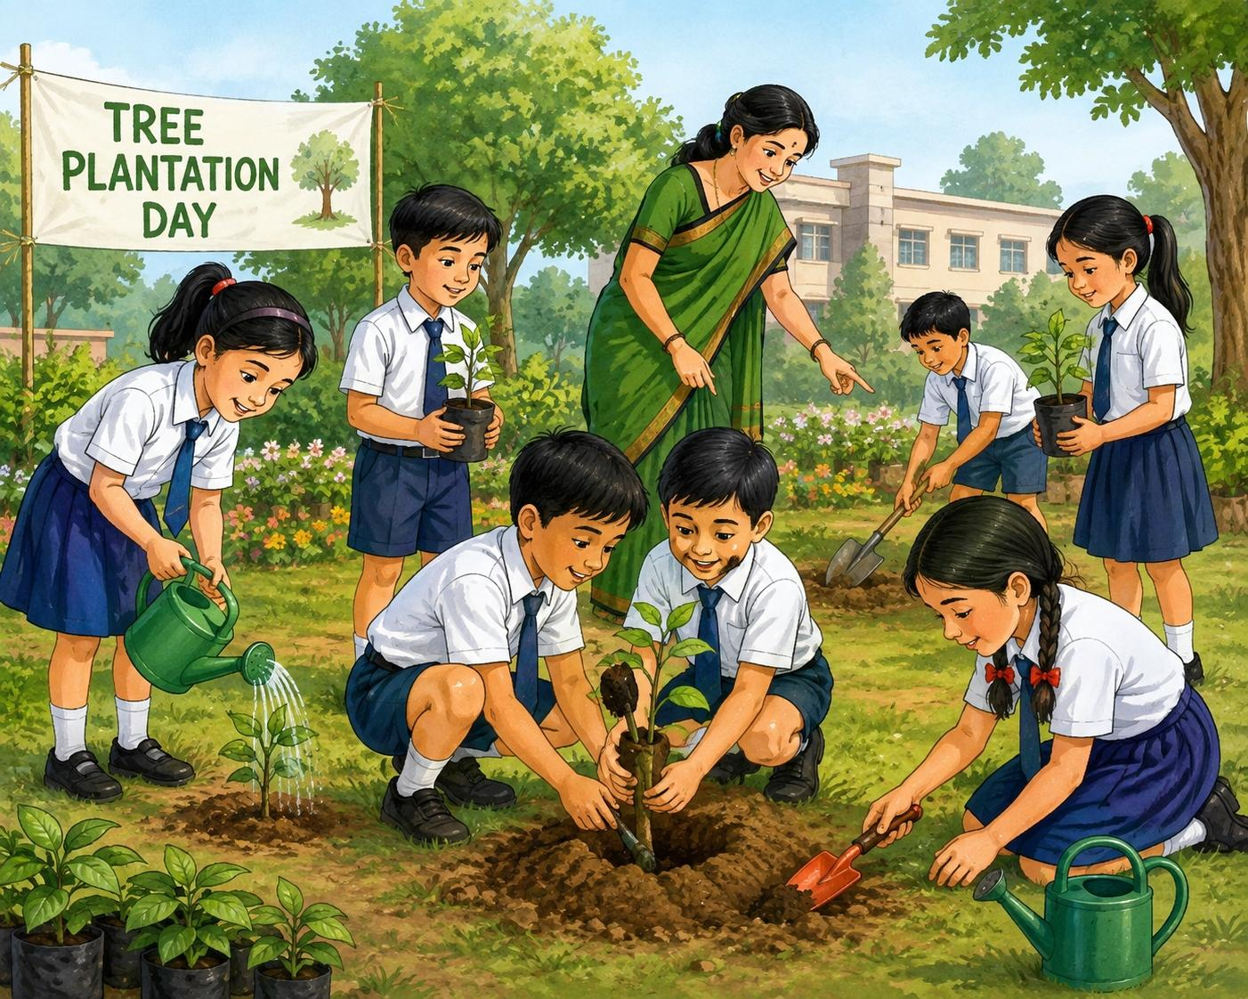

Tree Plantation Day
It is a bright and pleasant morning. The picture shows a group of students celebrating Tree Plantation Day. The students are planting small saplings in their school garden. Some children are digging the soil with spades. Two students are carefully planting a sapling in the ground. A girl is watering a newly planted sapling. Another student is holding a small plant ready to be planted. Their teacher is guiding and encouraging them. The children are working together happily. There are many green trees and colourful flowers in the garden. The school garden looks clean and beautiful. The activity teaches the children to love and protect nature. Trees give us fresh air and keep our surroundings green. Everyone should plant more trees and take care of them.

